SPC-DT Program Run Instructions

Version 0.1

July 21st, 2022

This document serves as run instructions for demoing the program and its features.

# Part 0: Opening the program.

To open the program, double-click the “SPC-DT.exe” file. It must be launched in the same directory as “glut32.dll” and “glut32.lib” files, but it should be already set up for that.

# Part 1: Loading the iris parser and dataset.

1. Upon opening the program, click the “Upload Parser” button.

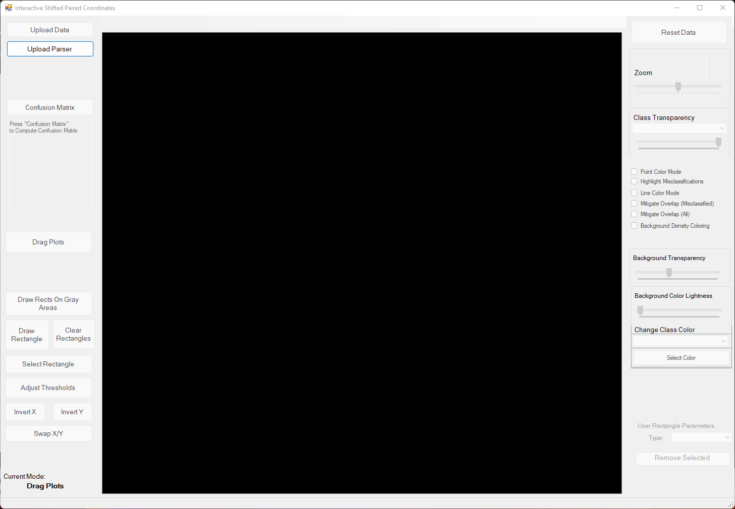

1. Select “irisParser.txt” A screenshot of a computer

   Description automatically generated with medium confidence
2. Next, select the “Upload Data” button. A screenshot of a computer

   Description automatically generated with medium confidence
3. Select “iris.csv”A screenshot of a computer

   Description automatically generated with medium confidence

# Parser 2: Modifying the Visualization

1. Select the change class color drop down indicated by the red arrow above, then select “1.”
2. Click the “Select Color Button” right below the red arrow. Chart

   Description automatically generated with medium confidence
3. Select a shade of red then click “OK.”
4. Do the same for classes 2 and 3 using different colors. After, your visualization should appear similar to this: Chart

   Description automatically generated
5. Next, try dragging the plots to the locations given here: A picture containing chart

   Description automatically generated
6. Use the “Invert X,” “Invert Y,” and “Swap X/Y” buttons in the bottom left to approximate the appearance in the following screenshot. To use, first, click the button, then click a plot to apply the effect. Once finished with a certain effect, click the button again or click the “Drag Plots” button. Additionally, turn on the “Point Color Mode” checkbox on the right of the screen.Chart, histogram

   Description automatically generated
7. Enable the “Highlight Misclassifications” checkbox to view cases that the decision tree has misclassified.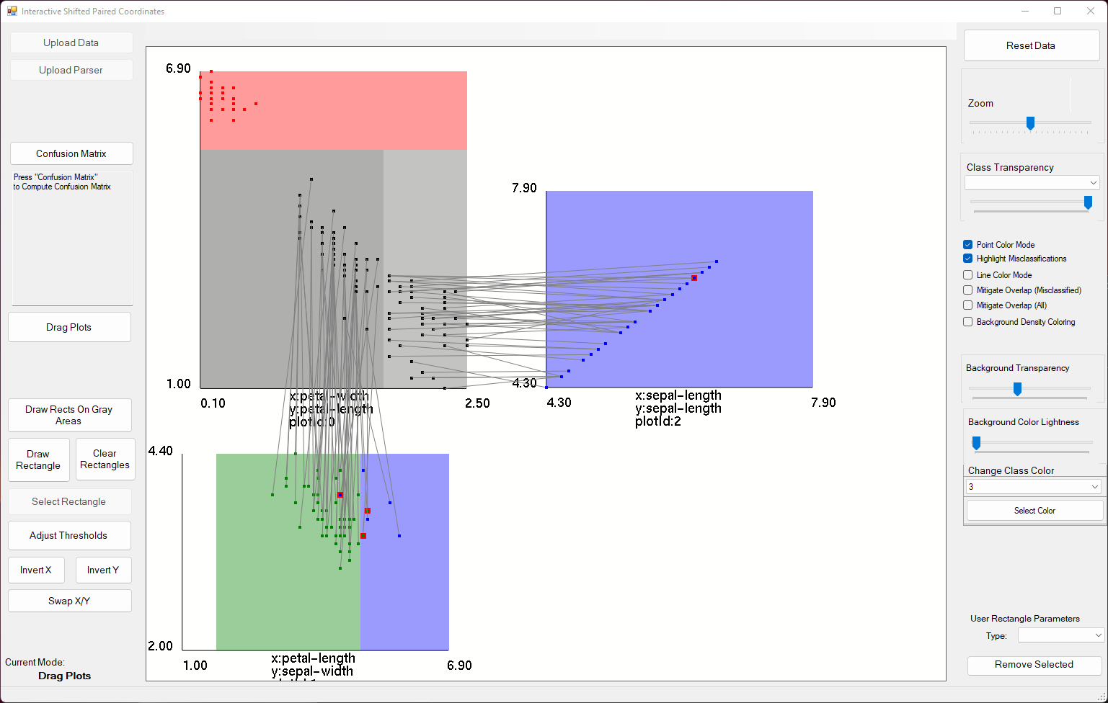
8. We can see a misclassified case on in plot2, but it is hard to tell if all cases leading to that point are being misclassified or only a few. To solve this problem, enable the “Mitigate Overlap (Misclassified)” checkbox on the right. This allows us to better see the misclassified cases.Chart

   Description automatically generated
9. Turn the “mitigate overlap (misclassified)” checkbox off, then click the “Adjust Thresholds” button in the bottom left. This allows us to click and drag the dark zone outlines.Chart

   Description automatically generated
10. Drag the line underneath the red zone at the top down to about halfway through the cluster at the bottom of plot0. Observe the change in performance of the decision tree.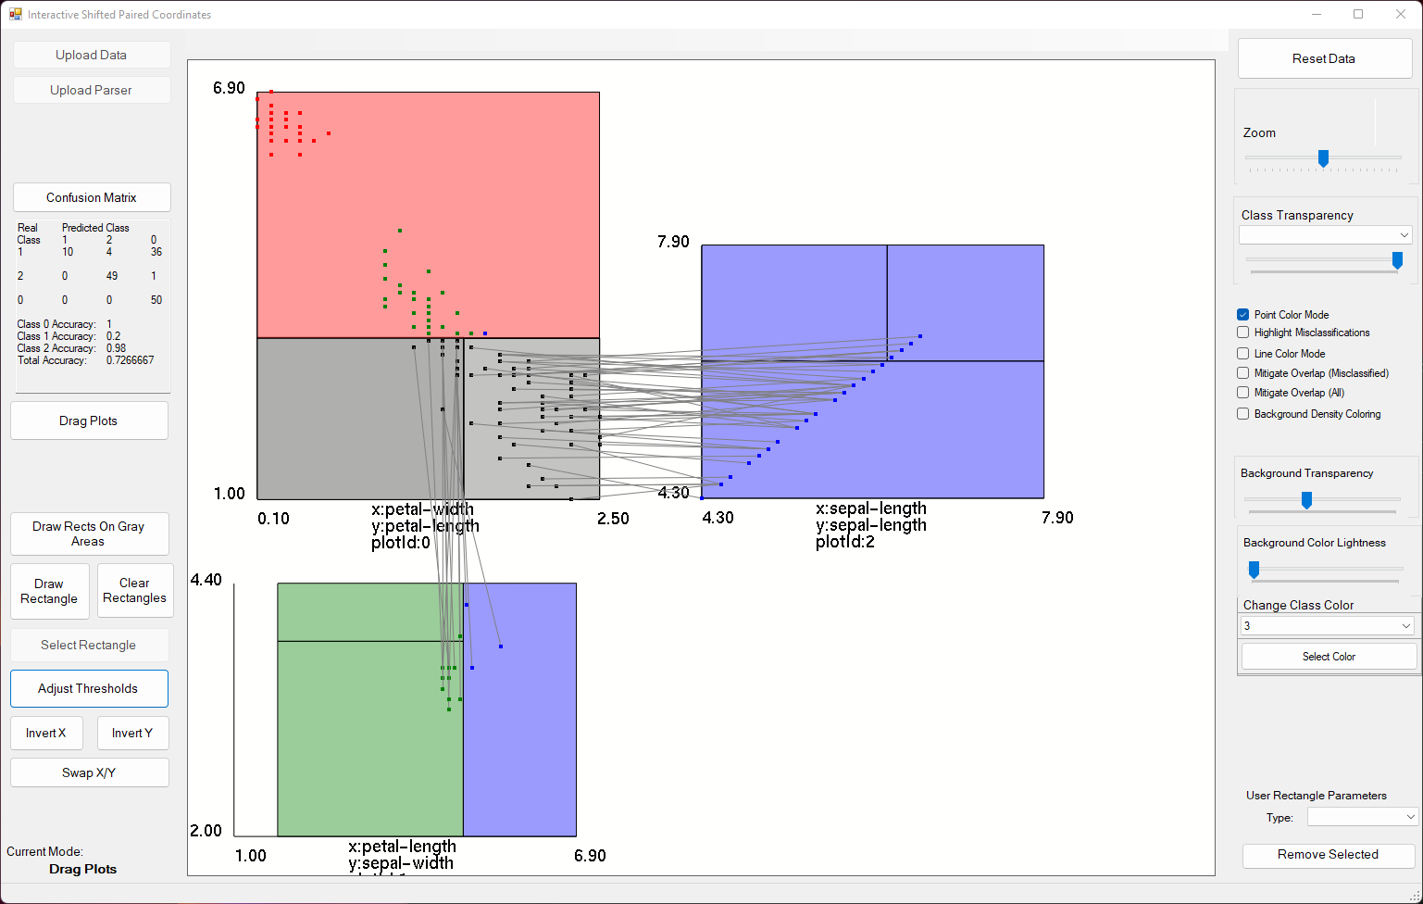
11. Click the “Adjust Thresholds” button to disable threshold adjustment, then press “Draw Rects On Gray Areas” to condense points on gray areas to a single point to make understanding the flow of the decision tree clearer. Chart

    Description automatically generated
12. Press the “Clear Rectangles” button to remove the condensing rectangles. Next, enable the “Background Density Coloring” checkbox on the right to color background zones based on the purity of the decision tree rule.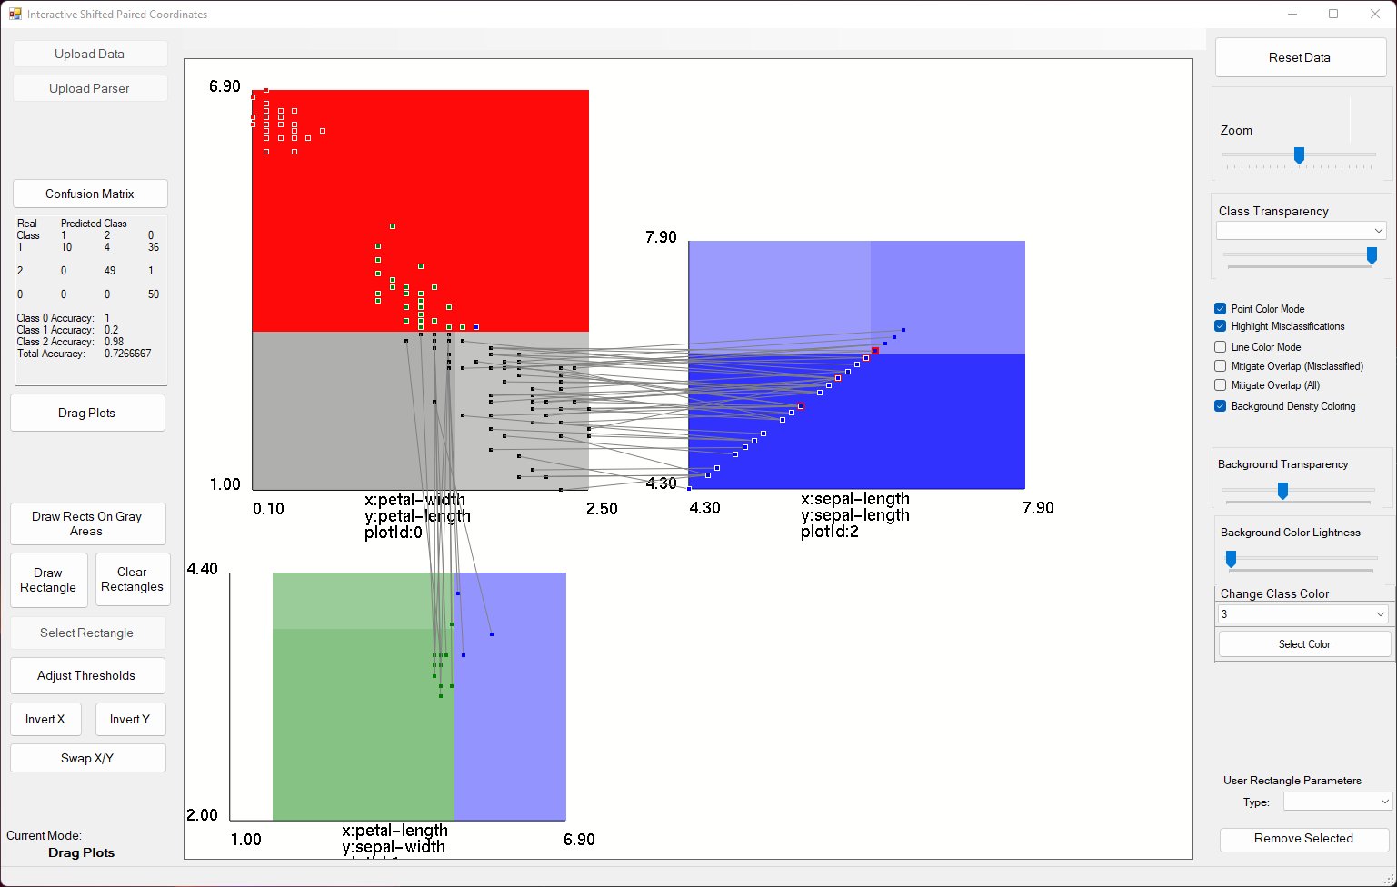

# Part 3: Other Datasets

Play around with the same concepts using the seedsParser.txt and seeds.csv files. Then apply what you’ve learned to a more complicated decision tree seen in the breastCancerParser.txt and breastCancer.csv files. **The program has to be closed completely to load a new dataset and parser.**